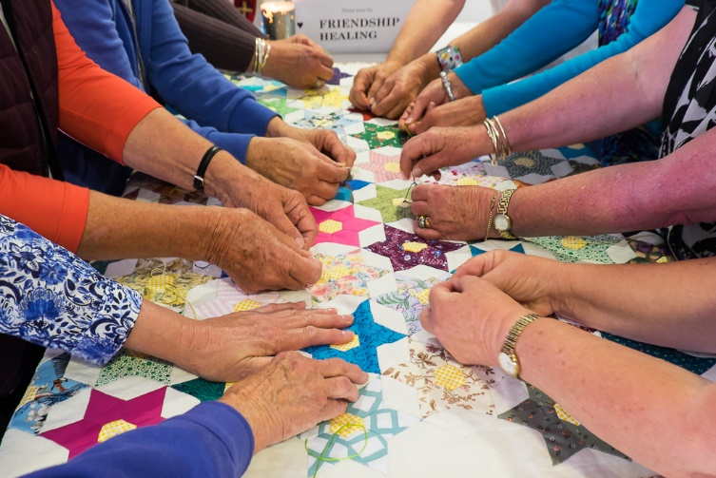

Can you touch a prayer? Can you pull it close and feel it’s comfort? You can if it’s part of a prayer quilt. Our parish is privileged to be the first New Zealand Chapter of the Prayer Quilt ministry.
What is a Prayer Quilt?

It is a statement of our faith and belief in God's power to comfort, strengthen and heal. Prayer Quilts are lap-sized comforters with prayers knotted into them. As each knot is tied prayers are offered for the person who is to receive the Prayer Quilt. When fully tied the Prayer Quilt is given as a gift of love and prayer. Anyone who is facing a special need for prayer - be it physical, emotional or spiritual - may receive a prayer quilt provided they accept the gift of prayer in this form.

"It's not about the quilt; it's all about the prayers.".

Our Chapter meet in the Parish Centre each Wednesday, 9am-noon. Please come and join us. We need people to help with sewing, sorting fabrics, making morning tea and a host of other tasks, or pop in and join us at around 9.45-10am for coffee & prayer time. We will be delighted to see you.

RECENT FEEDBACK FROM PRAYER QUILT RECIPIENTS
“Thank you all indeed. I feel so grateful and privileged to have received such a beautiful and meaningful quilt – explicitly vibrant. I love the colouring and with so many butterflies – God’s most beautiful creations. I shall treasure the loving prayers the parishioners have tied especially for me. Thank you also for the card included. I appreciate the assurance it gives me for the remainder of my life. I have felt stronger already and have enjoyed the warmth when tucked around my knees. God Bless you all, very talented ladies, Connie”

“Thank you so much for the prayer quilt you made me when my husband died. It, and the prayers for strength, courage & peace have supported me over the last months. Without our blessed Lord and people like you I could never have done it. With love & Blessings, Trish”

“A couple of days ago I received my prayer quilt & I must say that it is one of the most special things I have ever been given. Not only is it a beautiful quilt (I love the colours & patterns!) but the care, love and prayer that went into making it is so humbling. Seeing all the little knots & knowing each one was a prayer for me from someone feels like a huge blessing. It’s at these times that you get a grasp of that wonderful Christ-like love that gives so much without condition. I feel so, so blessed by those that have made this & I will cherish it dearly. Love & thanks, Stephen”

The prayer quilt has pride of place in our living room and gives us a lift when we think of those ‘strangers’ who have loved and prayed for us and put their thoughts and energy into supporting us. I am still humbled when I think of that. I feel excited for the first time in a long, long time. This has come through many months of surrender & learning what “trusting God” actually means and ultimately what it feels like. Hope. So there is now a slither of hope in my life & it seems to be streaming light over my entire being. God is good! Love, Kirsty”

Our prayer quilts covered us last night, from the prayers and supportive ministry – words are not adequate. Love Beryl & Gordon”

Words fail me. What a truly beautiful prayer quilt brought to me this morning. It’s perfect in every way, with all my favourite colours and my only challenge is in finding a place to put it that is worthy of its beauty & meaning. Thank you so much for thinking of me & my sincere thanks to your wonderful team for producing such a wonderful work of art. With grateful thanks, Wendy”

I just want to express to you my sincere thanks for the beautiful prayer quilt I have received. It is proving to be of great comfort and support for me. I know that when the stress & pain seems too strong for me the Lord hears our prayers and is always there for you & me. Thank you again & God’s richest Blessings on all who participated in this wonderful gift. Love, Jan”

